Comparison of Birth Year and Exit Year from AMA Graduate Data
By: George Holsinger
May be shared

For this project, I took a document with information on graduates from AMA and ran it through a program designed to get all of the entries that had both a birth date and an exit date. The main problem was that all of the entries are human entered and there was a lot of inconsistencies in how the data was entered. Before starting, we randomized the names on the records. The names are the real names of those who attended AMA, however they are not attached to the corresponding record to preserve anonymity.

The dataset we used contained a Name, Id Number, Exit Year, and Date of Birth/Death information. For this project, I was only concerned about the Exit Year and Birth Year, however I used the Id Number as a unique identification for each person and kept their name (again, anonymized) attached to the data as well. By the end, I also had an Age at Exit for each person.

The main issue I ran into was inconsistent data format. For example, Exit Year was sometimes a four digit number, sometimes a two digit number, and sometimes a single digit number. For this project, I assumed any one or two digit numbers were from the 1900’s (ex. 76 is 1976 and 4 is 1904).

I ran into a similar issue for Date of Birth. Since I wasn’t analyzing anything regarding Date of Death, any record without a Date of Birth was automatically not included. While there was a specific Date of Birth column, It was not very filled in. If the record had an entry in that column, I used it. Otherwise, I used the combined Date of Birth/Death column. The assumption I made here was that any Date of Birth/Death that wasn’t specifically labeled as a DOB/DOD was a Date of Birth. The rest of that column was organized in a ton of different formats that I was able to scrape through and extract the year from, applying the previous assumption about the 1900s to any two digit years.
The only thing I used the Age at Exit column for was to filter out any records that seemed to have inaccurate ages. A historian at AMA told us that the typical graduate was between the ages of 7 and 23. Using that information, we were able to restrict the data to that age group.

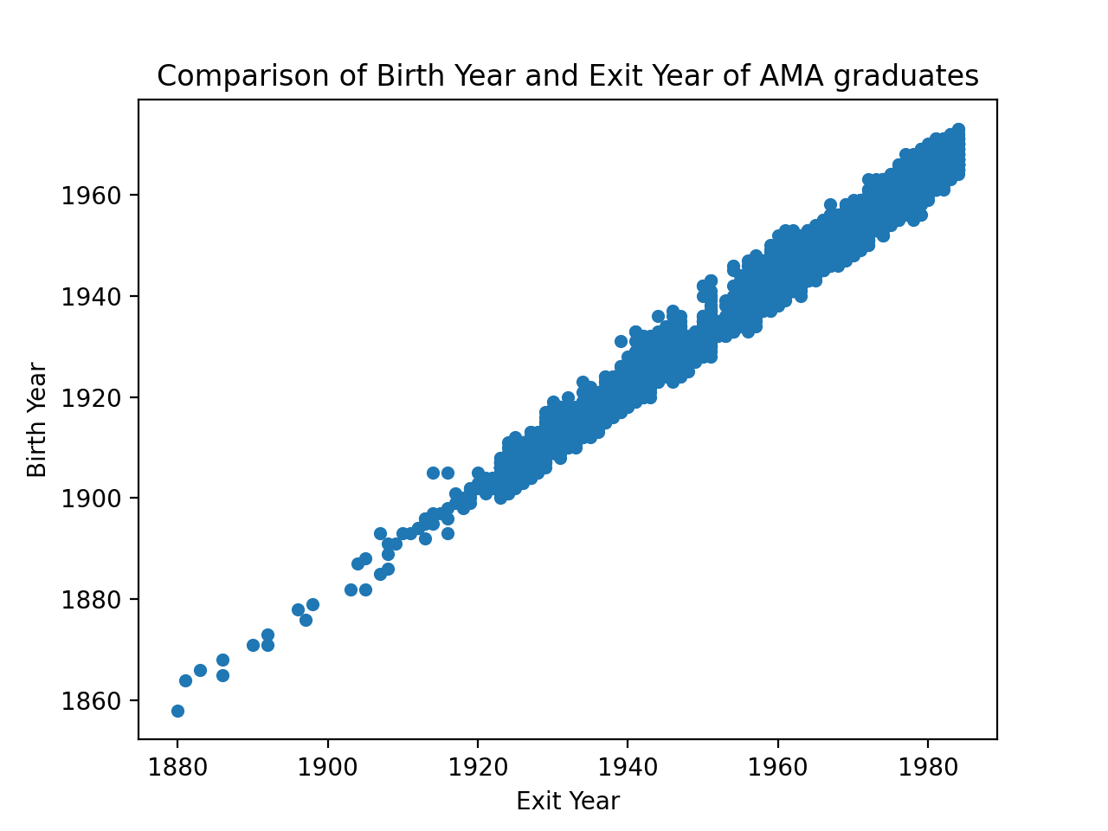
Figure 1. A comparison of Birth and Exit years

We can see a couple of things in Figure 1. First, we can see that the school only graduated a couple of students until around 1910 when it started picking up steam. From about 1920 onwards, the school had a wide range of ages graduating although it looks like there may have been a dip in the 1950s. Remember from earlier, we have filtered to the 7-23 age range for graduates. This is good but it doesn’t give us a great view of the information or trends.

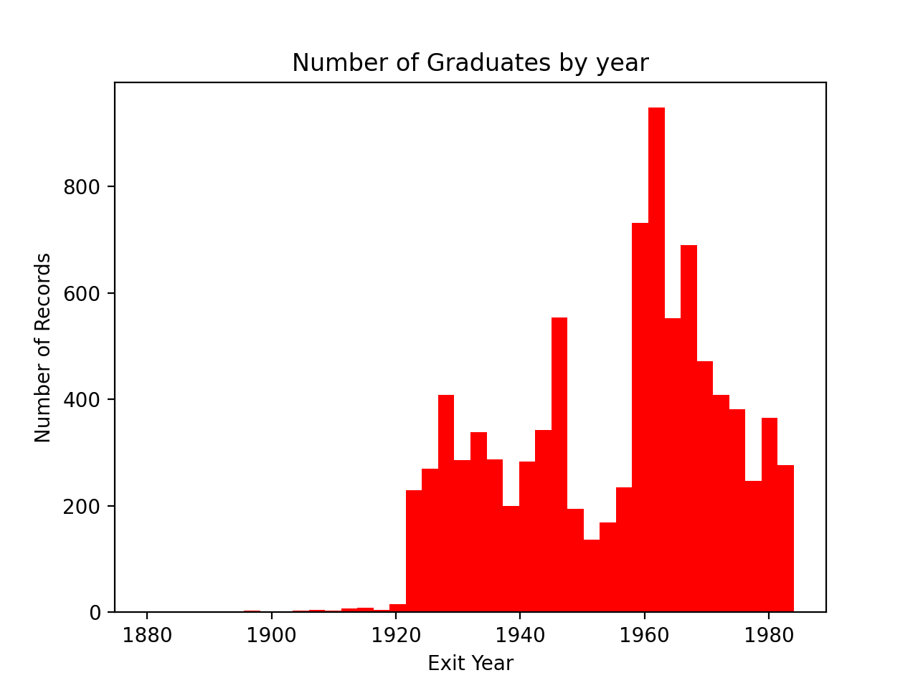
Figure 2. Number of Records by Graduating year

In Figure 2, you can see trends a lot better. Like we saw in the previous graph, around 1920 is when they started getting a lot more graduates. What we couldn’t see in the other graph is the dip around the early to mid 1950s. This is around the time of the Korean and Vietnam wars so my guess is that many youth who would be in school ended up overseas.

In conclusion, it seems that AMA had a consistent trend of graduating students from 1920 till its closure in the 1980s. I believe that the data from then onwards is pretty good. However, I do wonder what percentage of the data that we threw away is from the pre-1920 era and how many graduates were missed because of that. Other than that, it is cool to see the impact of the Korean and Vietnam wars on the graduating numbers. Hope this is helpful. The entire cleaned document should be included so you can look through on your own.

